# Internship Report-2022

# KINGOLOGIC INC

# LAHORE



**Mabtoor-Ul-Shafiq**

**2018-ag-8208**

**Horair Ahmad**

**2018-ag-8206**

**Muhammad Waqas**

**2018-ag-8224**

# BS-Computer Science

08-06-2022



*Department of computer science*



*University of Agriculture Faisalabad*



*Submission date:*



# KINGOLOGIC INC, LAHORE –Punjab – Pakistan

# Contact : +92303749302

1. **DEDICATION**

We dedicate this humble effort to the Almighty ALLAH, Who Is the creator of this universe, the cherisher and sustainer of this world….!! Lord of all things, Master of the “Day of Judgment” and have the power of all things. To Holy Prophet HAZRAT MUHAMMAD (PBUH) Who Is the greatest social reformer, the city of knowledge, who has guided his “Ummah” to seek knowledge from cradle to grave….!!!To My Most Honorable Parents Who Taught me the first word to speak, the first alphabet to write the first step to take

To All those, who burnt themselves, to make me candle.

**5. Acknowledgement**

The credit for the completion of the internship goes to a number of people. First of all, We are thankful to Allah Almighty for providing me strength and resources to carry out this internship. Then we want to thank my parents who provided me with unconditional love and moral support, so we became able to this in an efficient way. we also want to thank my group members who work like a team. we deemed it my outmost pleasure in expressing my cards gratitude with the profound benedictions to my worthy CEO Mr Ali Khurrum for providing me strategies and confidence at every step. Their guidance and efforts on me to achieve daily tasks and maintenance of the professional integrity will always serve as the inspiration of light thought my life.

We take this opportunity to express my deep regards to my consultant MR Awais Sikander for his exemplary monitoring and constant encouragement throughout the course of the internship. The blessing, help and guidance given by him time to time shall carry me a long way in the journey of the life on which we are about to embark. We are extremely grateful and remain indebted of Kingologic Inc for being a source of inspiration and for his support. We are obliged to all members of Kingologic Inc for the valuable information provided by them in their respective fields. We are grateful for their cooperation during the internship.

We are thankful to them for their continual constructive criticism and invaluable suggestions and help, which benefited me a lot at my intern.

**6. Executive Summary**

The internship is a great chance for the students to grasp the various facts about the working environment in companies during their studies. It will help us in job perspective­My internship program was with Kingologic Inc of Pakistan in LAHORE. We were involved in Machine Learning. In Kingologic inc, We did our whole work under the supervision Of Ali Haider rana. He is very cooperative and nice person. He is regular, good instructor and a well-mannered person. Our objective in Kingologic Inc is to assign detect the food vision mini using Transfer Learning. To complete this project, We learn many new techniques like tensorflow, numpy, pandas …. etc. We Completed this project by achieving the daily task assigned by Supervisor. The project consists of entities of student, teachers, institutes and parent. The project helped us by increasing our practical knowledge in depth. We acquired new technical skills throughout our work term. We also brushed our skills in Tensorflow and Keras API while working in Transfer Learning . Most importantly, the work experience was very good which included good fellowship, cooperative teamwork and accepting responsibilities.

**7. TABLE OF CONTENT**

Description of content

Title Page …………………………………………………………………. 1

Dedication ………………………………………………………………….3

Acknowledgement …………………………………………………………3

Executive Summary ……………………………………………………….3

Scan copy of certificate ……………………………………………………6

Overview of the Organization ……………………………………………..7

Brief history ……………………………………………………………….7

Introduction of the organization …………………………………………..7

Policy of the organization …………………………………………………8

Organizational Structure …………………………………………………..9

Organizational Hierarchy chart ……………………………………………9

Number of employees ……………………………………………… …….9

Main offices ………………………………………………………………10

Introduction to all the departments ……………………………………….10

Plan of internship program ……………………………………………….11

Brief introduction of the office of the organization ………………………11

Starting and ending dates of internship …………………………..............12

Names of the departments in which got training …………………………12

Training Program ………………………………………………………….12

Description of the operations performed by the department ………………12

Detailed description of the assigned project ……………………….............13

Reflective Journal Entries ……………………………………………….…18

Interpret the events ………………………………………………………….19

……..

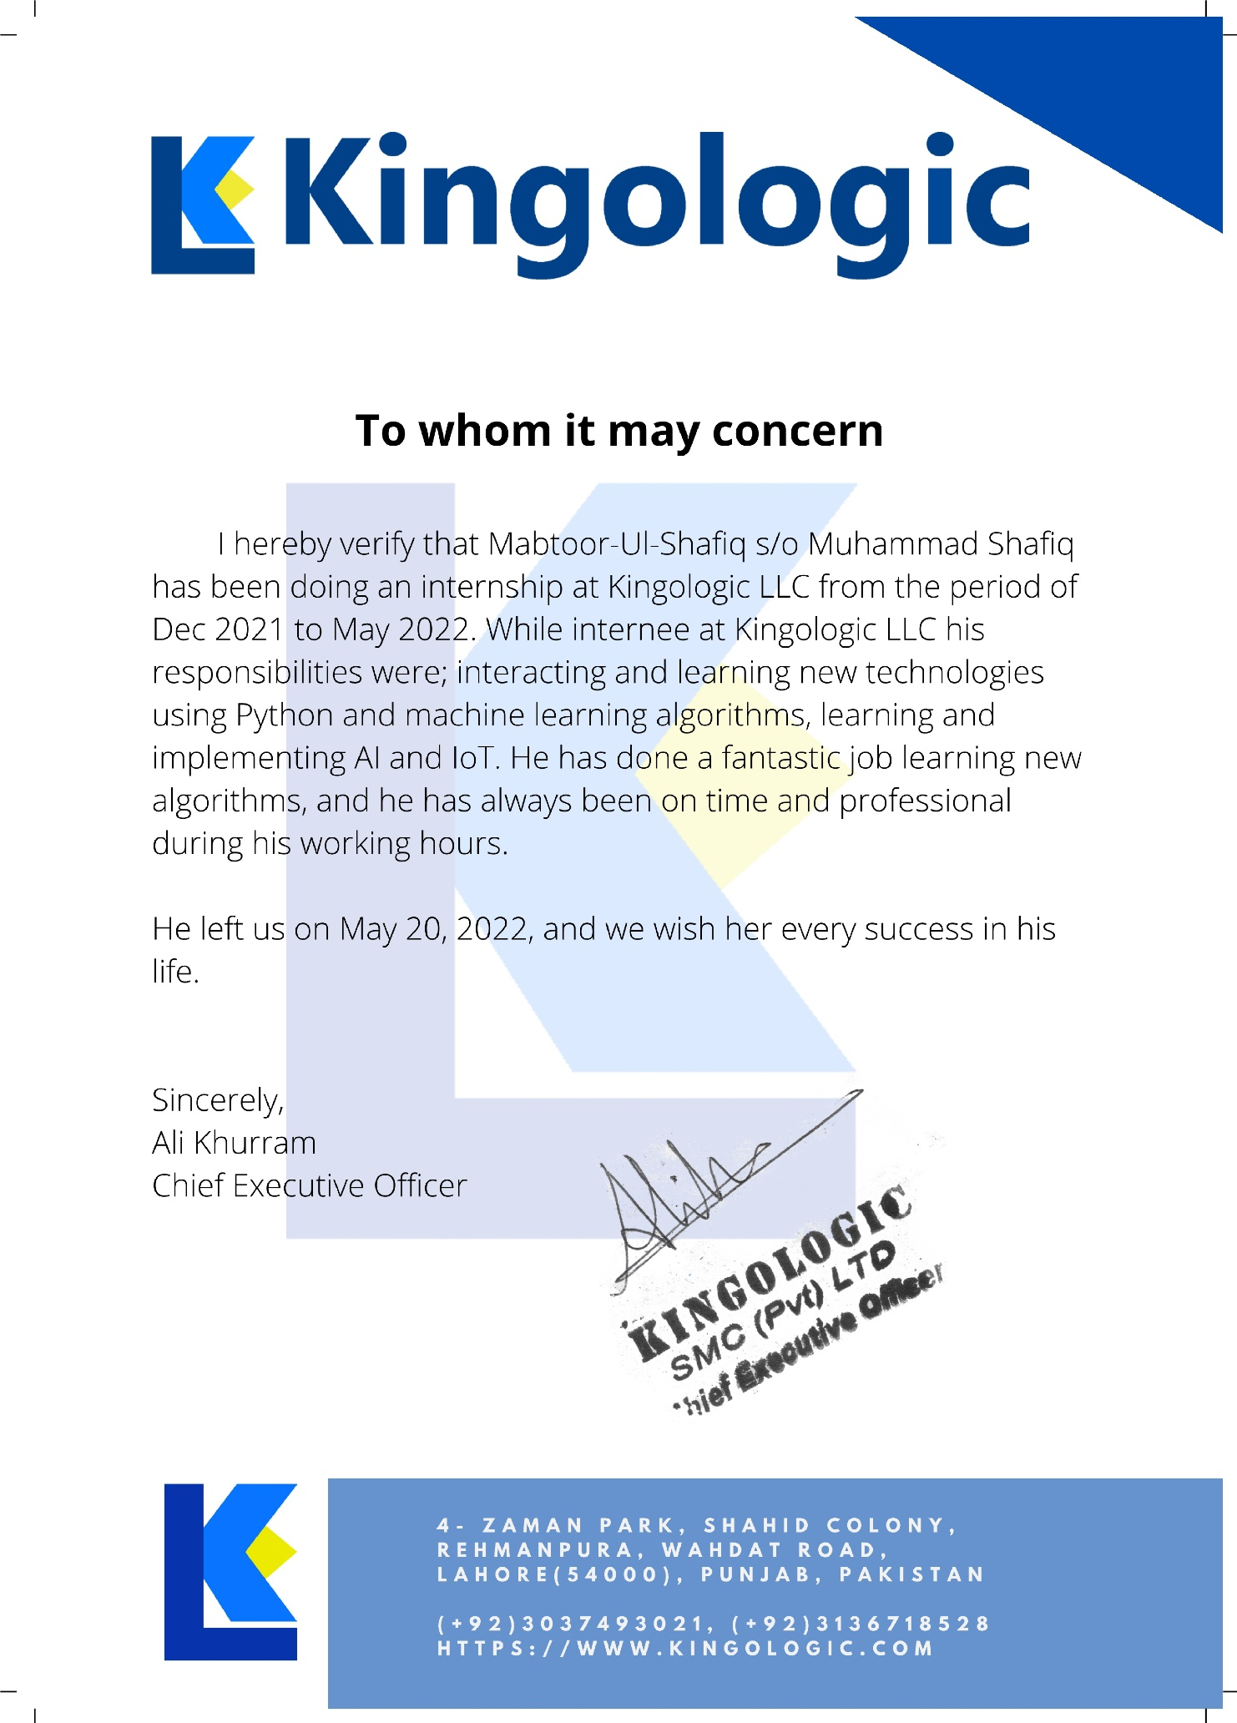

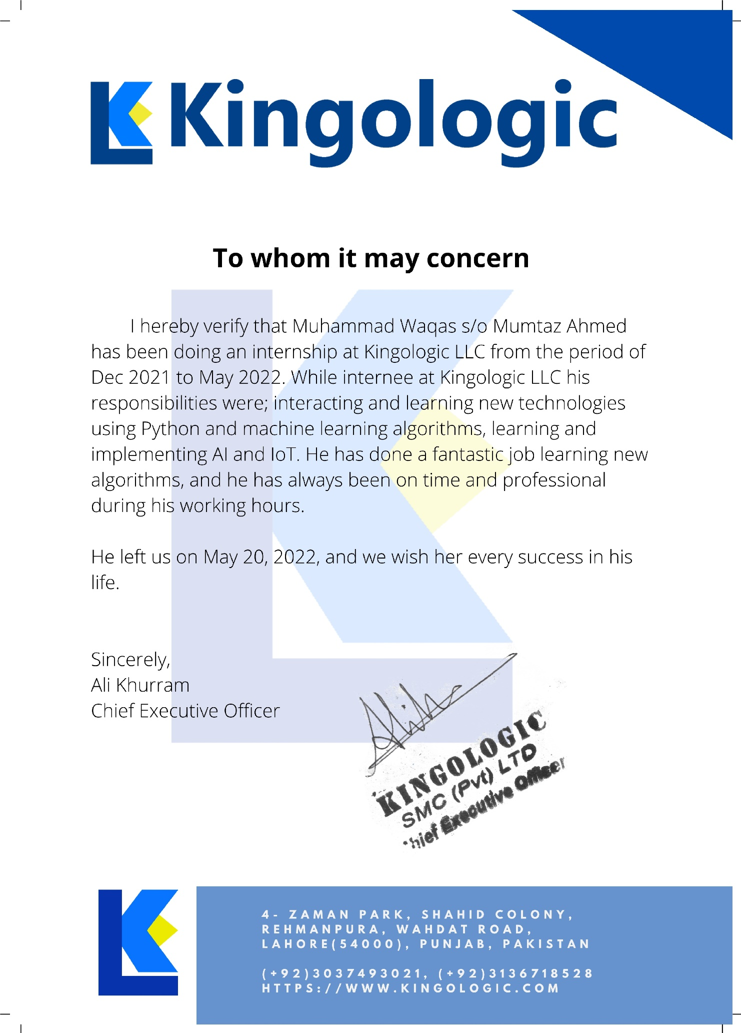

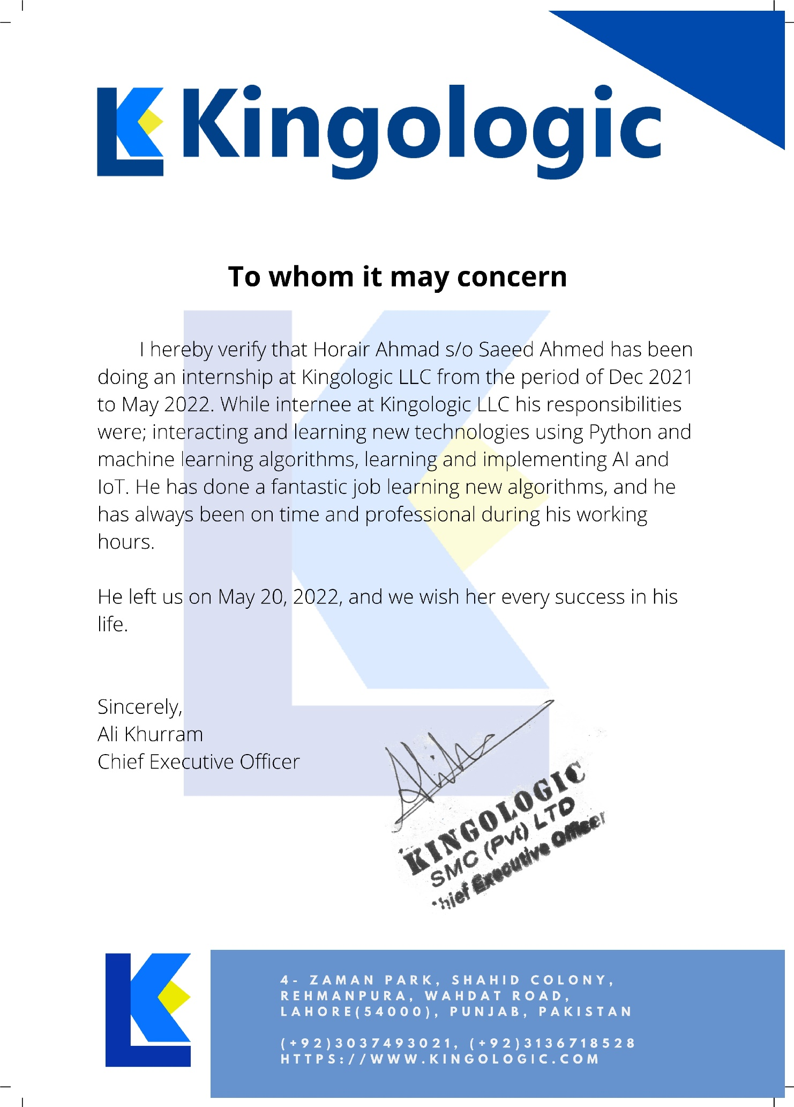

**8. Overview of the Organization**

* 1. **Brief History:**

Kingologic LLC was formed in 2009 to give graphic designing and PHP administrations, however, we immediately perceived the capability of the Enterprise-level programming joined with moral, painstakingly sharpened web showcasing procedures to convey achievement. We likewise accepted that this achievement must be accomplished if customers felt totally upheld by their advanced accomplice – an organization with the human touch, an organization like us.

From that point forward, we’ve never stopped. Truth be told, workplaces now in Lahore, Spain, Chicago(USA).City Marbles

# Introduction of the organization

# kingologic have envisioned, made, created, and upheld some momentous Progressive Web Apps. From the games business to retail and cordiality, to learning and improvement, our group sees exactly how significant the client venture is likewise convey the right result for our customers and the end client. This could be anything from working on somebody’s satisfaction to making them snicker or saving them time with regular assignments. Our customers trust us and that is the reason they work with us for quite a long time. We assemble solid bonds with them since they realize we convey the results they need. Kingologic center the results our customers need. Higher perspective reasoning is the way to what exactly will make our customer’s business bloom and develop. It’s more than execution-based showcasing and programming and web advancement

# Services:

* Web design
* Web application
* Enterprise Software Development
* Web development
* Mobile Development
* SEO
* AI and Machine Learning
  1. **Policy of the organization**

“WE TRAINED YOU AS PER YOUR FUTURE NEED”

# We work from an exceptionally cool space with high roofs, the right energy to permit us to be inventive and buckle down. In any case, we comprehend the equilibrium on letting off a little steam and have established a climate that actuates discussion, unwinding and connection with associates, teaming up, learning and developing our insight, cause let’s face it probably the best thoughts you think of aren’t sitting before a work area, yet examining the potential outcomes. Feel empowered. Believe in yourself. Be responsive and innovative and do what it takes to make our clients smile. Be our own customer so that we treat customers as our souls. We don’t want to just be ok at our jobs we want to be the best – set the bar high. We build small, great, global teams. We believe in 10x developers so that our clients can see the magic.

**9 .Organizational Structure**

Organizational Hierarchy chart

Owner

Fayyaz Khan

CEO

Ali Khurrum

Manager

Rajab Garcia

Senior Developer

Mihraj Din

Senior Developer Ali haider Rana

# Number of employees:

In this institute number of employees is round about 20 well brilliant hard worked employees in this institute among them round about 10 Developers in this institute. In this institute Admin, Teachers and other staff are working very hard whole the day. All the employees work very hard to carry out their responsibilities and different tasks. Well experienced staff work very diligently to create different

ideas and projects, and deal with customer/clients to hand over or receive the projects. This institute has many Deep Learning Engineer, Software developer, Web developer, Graphic designer and many others. The SEO (search engine officer) also control the management of projects and server clients and promote projects. This institute provides higher education facilities to comparatively less developed region of Punjab. Due to the need of the area the employment rate of the graduates of this institute is very high. That is why the popularity of its various programs is on a continuous rise.

# Main offices

Address: 150 N Michigan Ave Suite 800, Chicago, IL 60601

Email: support@kingologic.com Phone # +17736760004

# Introduction of all the departments

Development department SEO department

IT technology department

Comments on the organizational structure

First on the top manager/admin is main head of software house. Two person’s developer and assistance manager after manager. All employees and developer work under manager.

Sub ordinates.

**10. Plan of internship program**

1. **A brief introduction of the branch/ area office of the organization**

The Kingologic inc was established as the highest seat of learning in teacher education with clear goals and objectives of producing quality teachers of international standards. Approximately 60. SEO Workers 15 and Employees in Development is round about 30 and 15 Developers. It was ranked as one of the top institutions of higher learning in Pakistan. Among other related objectives set before the Kingologic inc, some are to:

* Bring quality change in education focusing on teacher education. Give proper guidelines.
* Working discipline is very great in this institute.
* Promote governance, leadership and management skills among educational managers.
* Promote teaching and learning innovations.
* Develop human resource for educational institutions and other areas of high social and economic need.
* Establish linkages with national and international educational institutions and the society.
* Web projects deals with manager is almost great. SEO working staff is very hard work in this institute. Developers is about 15.
* Manager is well experienced and hard work in his field. Other developers also great hard worked in her fields.

The Kingologic inc is a famous IT/Development Institute are striving to achieve high standards of success through innovation, creativity and looking for strategies. Kingologic inc designed curriculum and established instructional to provide opportunity to its students and staff of experimental and experiential learning. This encouraged and enhanced conceptual learning and application. The media laboratories serve as modern gadget to access the virtual material for learning and research by students and Zee Solution.

In addition to offering degree programs, the Kingologic inc adopts multi-pronged strategies like WEB development through holding workshops, seminars, short and advanced courses. This program focuses on capacity development of the staff and students in response to the emerging needs of the time. Students are motivated to learn the art of peaceful co-existence and finding solutions to the problems through dialogues and discussions. Due to such significant changes could be observed in the outlook and behavior of the students.

# Starting and ending dates of internship

I have completed internship started from 31/12/2021 and ended on 20/05/2022.

# Names of the departments in which you got training and the duration of your training

I got training in Web development department of Machine Learning. Duration of my internship was 4 Month started from 31/12/2021 to 20/05/2022.

**11 .Training Program**

**a . Detailed description of the operations of the department.**

Determination of operational feasibility by evaluating analysis, problem definition, requirements, solution development and proposed solutions. Documents and demonstrates the solution by documentation, flowcharts, layout, diagrams, charts, code comment and clear code. Prepares and install solution by determining and designing system specification, standards and programming. Improves operations by conducting system analysis; recommended changings in procedure and policies. Obtain and license the software by obtaining required information by the vendors recommending purchases testing and approving products. Update the job knowledge by studying the state-of-the-art development tools, programming techniques and computer technologies. Provides the information by collecting, analyzing and summarizing development and service issues.

Develop software solutions by studying information needs;

Studying system flow Data usage

Work progress

Investigating the problem areas Documentation of the records. Maintaining the dataset.

Assigning daily tasks.

Evaluation of the task.

**b. Detailed description of the project assigned**.

Assigning project of food vision big model using transfer learning, I firstly try to built this model using convolutional neural network by using some convolutional layers and max pooling layers. To improve our model(s), we could spend a while trying different configurations, adding more layers, changing the learning rate, adjusting the number of neurons per layer and more. However, doing this is very time consuming. Luckily, there's a technique we can use to save time. It 's called transfer learning, in other words, taking the patterns (also called weights) another model has learned from another problem and using them for our own problem.

There are two main benefits to using transfer learning:

* Can leverage an existing neural network architecture proven to work on problems similar to our own.
* Can leverage a working neural network architecture which has already learned patterns on similar data to our own. This often results in achieving great results with less custom data.

We're going to be building Food Vision Big™, using all of the data from the Food101 dataset.

Yep. All 75,750 training images and 25,250 testing images.And guess what?This time we've got the goal of beating DeepFood, a 2016 paper which used a Convolutional Neural Network trained for 2-3 days to achieve 77.4% top-1 accuracy.

Top-1 accuracy means "accuracy for the top softmax activation value output by the model" (because softmax ouputs a value for every class, but top-1 means only the highest one is evaluated). Top-5 accuracy means "accuracy for the top 5 softmax activation values output by the model", in other words, did the true label appear in the top 5 activation values? Top-5 accuracy scores are usually noticeably higher than top-1.

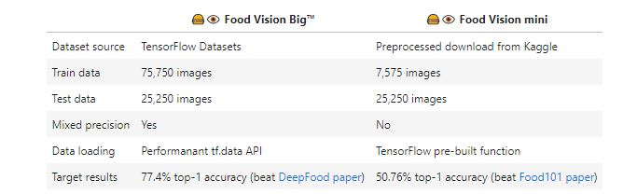

We Discussed the few topics:

* Using TensorFlow Datasets to download and explore data
* Creating preprocessing function for our data
* Batching & preparing datasets for modelling (making our datasets run fast)
* Creating modelling callbacks
* Setting up mixed precision training
* Building a feature extraction model
* Fine-tuning the feature extraction model
* Viewing training results on TensorBoard

By applying Feature Extraction, I’ve got 70% of accuracy and 71% of validation accuracy

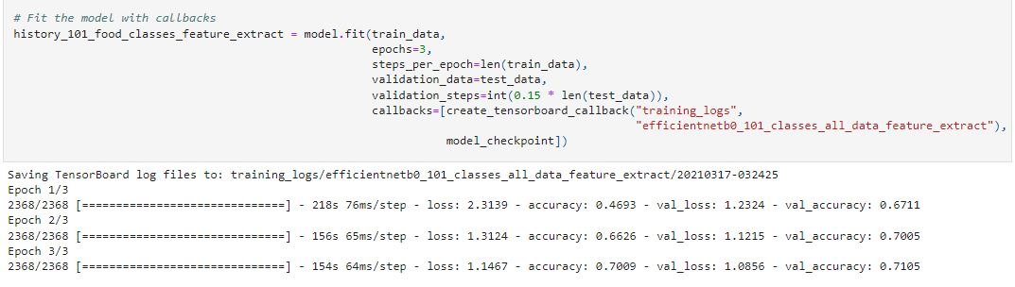

After feature Extraction, I tried to unfreeze last 5 layers and apply fine tuning. After applying fine tuning, I’ve got 97% accuracy and 80% validation accuracy.

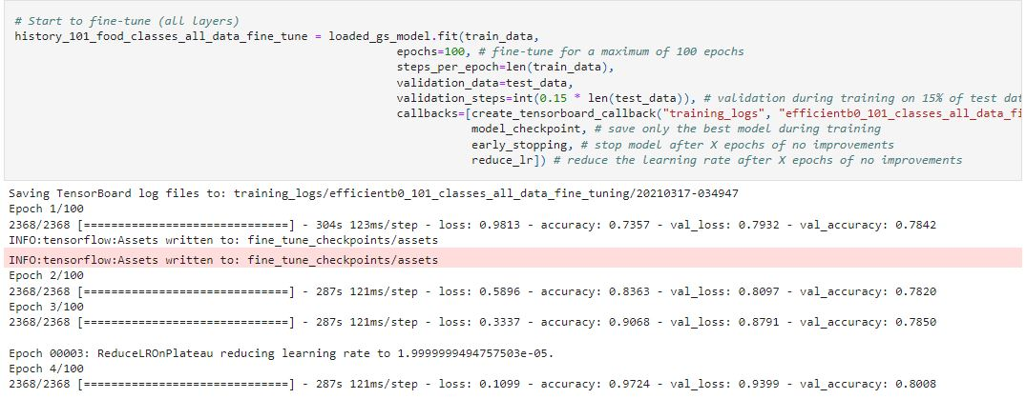

# Deep Learning Model:

# This project consists to beat the deep food paper by getting best accuracy and least loss.

# Team:

The other team members were Muhammad Waqas and Horair Ahmad under the supervision of Awais Sikander. He is senior developer and I learn many things from him. From developing deep learning model to get best accuracy, he has taught me many important things. I felt myself very lucky to get such a mentor and supervisor. My team members showed good team spirit during complete internship.

# Technologies:

* Tensorflow
* Keras API
* Numpy
* Matplotlib
* Pandas
* Sklearn

# Solved Bugs & development features:

Developing the Model in Transfer Learning, new task for me. Errors and bugs consumed lot of time, but every bug taught me new thing. While practicing code first technique I faced hard time but due to experienced supervision I resolved it.

**Challenges:**

Utilizing Deep Learning model in any project was a big challenge. I have learned many things while working on it and at the same time faced many challenges. The main challenge was to understand the concept of feature extraction and fine tuning in transfer learning. It was also a challenge to learn new technologies and apply them properly. I would again like to thank my supervisor for helping me to overcome these challenges by his guidance.

**Technologies and tool learned:**

**Tool:**

Google Colab

**Technologies:**

* Tensorflow
* Keras API
* Numpy
* Pandas
* Matplotlib
* Scikit-learn

**Tensorflow**

# TensorFlow is a free and open-source software library for machine learning and artificial intelligence. It can be used across a range of tasks but has a particular focus on training and inference of deep neural networks.

# Keras API

# Keras is a deep learning API written in Python, running on top of the machine learning platform TensorFlow. It was developed with a focus on enabling fast experimentation. Being able to go from idea to result as fast as possible is key to doing good research.

# Numpy

# NumPy is a library for the Python programming language, adding support for large, multi-dimensional arrays and matrices, along with a large collection of high-level mathematical functions to operate on these arrays.

# Pandas

pandas is a software library written for the Python programming language for data manipulation and analysis. In particular, it offers data structures and operations for manipulating numerical tables and time series. It is free software released under the three-clause BSD license.

**Matplotlib**

Matplotlib is a plotting library for the Python programming language and its numerical mathematics extension NumPy.

**Scikit-learn**

Scikit-learn is a free software machine learning library for the Python programming language. It features various classification, regression and clustering algorithms including support vector machines.

.

**12 .Reflective Journal Entries**

**a. Describe objectively what happened**

In the beginning of the joining lectures were given on the effective development plan. In these lectures, we were taught different management skills that help me in all time during my internship. The lectures were included on these topics:

# Time management.

* Team work.
* Communication.
* How to deal with ambiguity.
* How to start project.

# What are the essentials of the project.

My objective here in Kingologic inc is to Develop Food vision big using Transfer Learning. The reason for building the Food vision big in transfer learning is to beat the deep food paper by getting best accuracy and least loss. Development in Deep Learning is going popular and has bright future in the field of development. The main objective of this task is to Beat the deep food paper.

The above written reasons encouraged me to develop a system for the institues for the Kingologics. The Development department of the company first assigned me task to get the dataset for the project. The requirements gathering is one of the major parts to develop the model and most of time was spent to gather the requirements analyze them and then documented them. After that department of development assigned me task to document the project or in other words paper work for Food vision big model before starting coding. Every day I reached there on time. My respected sir deal with me very kindly and communicate with me heartedly and as a team leader. There way of assigning assignments is very comfortable. There way of training me is also very comfortable and I also comfortable on their training way. Every day he teaches me how to communicate with client and how to meet or satisfy the client requirements. After working in three hours, I take a little break for refreshment. After that we start our work again. Every day my working and development skills

# 13 .Interpret the events

**What I saw and hear**

At Kingologic inc, there is no one to take orders like, “do this work”, and “do that work”. Everyone is assigned a particular work and he does his work in his own way. At the end of work everybody communicates his work with other members and every show their performance to others. I saw and learned team work in this institution. All the projects are done in this way. I saw appreciation among the team members as they appreciate their team members that is the motivation for the members. This institution was full of fun and creative and very much friendly. As an intern these attract me very much and I always try to follow the successful Software Engineers and developers to be a good developer as well as successful man. I have tried my best to learn about my project as well as other fields in Zee Solution.

I have worked as a member of a team, misunderstanding is possible in team. To be very frank, I have made many mistakes during the project, but my project manager had never been harsh with me. This practice is very affective to keep the work healthy. Kingologic inc follows a great standard of pure software engineering and their product quality is very high. Time to time code is reviewed so that better quality software is developed. I tried to maintain the standard of work from my side.

# New insights

I joined Kingologic inc at an intern to learn and apply my knowledge. So, I always had an attitude to be involved more into the project and be beneficial for both myself and the company. So, from my point of view, I have always been enthusiastic in my work. I have got very nice and friendly mentors and supervisor who taught me really well. They were never annoyed to answer even to my stupid questions.

# Connection with other learning

I learned at Kingologic really well and I would like to thank my teammates for that. I could catch everything that they have been telling me. I was first assigned to an internal project first, and when my team leader found me sincere to my work.

# Hypothesis and conclusion

The internship program helped me to gain important knowledge on software industry, their culture, work environment and all about web development. The internship program has increased my team work capabilities as well as respect to the team mate’s ideas and suggestions. Team discussions like brain storming sessions helped me identify and solve numerous problem issues which would have been impossible to solve otherwise. I would like to convey my thanks to supervisor for providing me an opportunity to gain idea of the competitive environment in the professional field. It has certainly lifted my software development skills in terms of design and coding. I now look forward to facing the upcoming challenges of the world.

# Evaluation of effectiveness and efficiency:

During my internship, I have learned how to be a true manner developer. The activities of the senior developer in Kingologic inc and their method of work enhance my mental ability to think as developer. The development environment improves my personality as a developer. Throughout my internship, I could understand more about the definition of a developer and prepare myself to become a responsible and innovative technician in future. Along my training period, I realize that observation is a main element to find out the root cause of a problem. Not only for my project but daily activities too. During my project, I cooperate with my colleagues and operators to determine the problems. Moreover, the project indirectly helps me to learn independently, discipline myself, be considerate/patient, self-trust, and take initiative and the Ability to solve problems. Besides, my communication skills are strengthening as well when communicating with others. I always observe my senior’s activities and try to adopt them. I learned from them how to be an effective developer. I copy their effective developer habits as follows.

# Work on basis:

As it is true for any developer, the conceptual understanding is the key for success. Unless one has strong conceptual foundation. The core conceptual understanding helps me in designing and implementing the best solution in the best possible way. Whenever an error occurred in project to feel gap in core concepts I start again from the basics of Deep learning.

# Putting tags and writing comments during code writing:

One thing I realized during this period of learning separating line between good programmer and rest is that zeal to know what and how it is happening. There is small group of people who can never leave a code without knowing exactly what is happening when it executes. I understand that in tight deadlines, we don’t get this liberty always and hence have to leave the code just knowing that it’s doing its job. Although this is a bit different topic of how to handle such situations, but as a programmer one can always try the level best to dig into as much as one can. And believe me, this becomes a habit with time and then you do it unknowingly every time.

# You learn more by helping others:

Most of us have a common tendency of turning our heads towards forums or groups only when we need help. And again, a clear separation between the good programmer and rest that the formers visit these places more often to help others. This makes them learn more then they learn to get their problem solved by someone else. Within a team as well, help others to solve their problems. Believe me, understanding others’ problem in their context, investigating on that and providing solutions; will leave you much more learned than before.

# Write simple, understandable but logical code

As in almost every aspect of life, the formula of KISS (Keep it simple and short) works in programming as well. Write more logical code and avoid complexity.

Sometimes people do write complex code just to prove their capability to write such codes. My experience says that simple but logical codes always works well, resulted in fewer issues and are more extendable. I remember an excellent quote

Good code is its own best documentation. As you're about to add a comment, ask yourself, "How can I improve the code so that this comment isn't needed?"

~Steve McConnell

Spend more time in analyzing the problem, you’ll need less time to fix it

Spend more time in understanding and analyzing the problem and designing solutions for it. You will find the rest of the things quite easily doable. Designing not always mean using modeling languages and tools, it can be as simple as looking at sky and thinking solution in your mind. Those who have habits of pressing keyboard (for coding) the moment gets the problem, usually ended us something different than the requirement.

If you cannot grow the overall structure of a program while taking a shower, you are not ready to code it. ~Richard Pattis

# Be the first to analyze and review your code

Although a bit difficult but try to break your own code before others can and with the time you will learn to write close-to-bug-free code. Always do a close and unbiased review of your code. Also, never hesitate to take others view on your code. Working with good programmers and taking their feedbacks will surely help you become a good programmer.

# Work-arounds don’t work for longer time

Many times, software programmers implement work around solutions (may be because of lack of time, lack of problem understanding or lack of technology experience). But over the period these work around solutions always resulted in corrupting the code, making it less extendible and maintainable and lot of wastage of time later on. Always prefer to implement when you know the in-out of the solution. I understand that it becomes unavoidable in some circumstances, but it’s like, one should speak truth always, but you tell lie in some circumstances.

# Read documentation

# One of the essential habits of good programmer that I learn from my seniors is that they read lots of documentation. May it be specifications, JSR, API documents, tutorials etc. Reading documents helps you creating that essential foundation based on which you program in best of the way.

# I didn’t have much chance to make decisions in Kingologic inc. But I took the decisions of my own works like complete the assigned task and functional behavior of the website. I would say my performance was outstanding in Kingologic inc. Because, I have become a trusted body for my co- workers. They find me to be dependable and rely on me. The responsibilities assigned to a person can define his performance. And I have got many responsibilities towards my project and my co-workers. This expresses my performance at Kingologic inc I have always been confident about myself that if I try to do something, I will succeed.

**Recommendation and usability of training**

Internal recommendations should be one the most effective means of filling positions at a company. Good workers know other good workers and having an internal referral focus will assist that company in finding good candidates who should already be a culture fit, assuming the internal referral is coming from someone who is considered a "good" employee. One thing to be careful about though is offering internal referral bonuses. Your workers should want to provide internal referrals because they are excited about the position and want their friends to work there, doing it because it changed the culture of the referrals because people were not just doing it for the money so were more likely to provide poorer candidates